**ASSIGNMENT TRACKER**

**PROJECT DESCRIPTION:**

We are living in an era where technology is developing so rapidly around us. Technology is developing more rapidly than the humans can notice. Technology has taken over our daily lives. So much so that it is hard to find someone without a smartphone these days. Nowadays, even the businesses are developing apps that can be used on the mobile. It has become a new platform for the businesses to grow their market. It has become a necessity for a business to have an app to flourish in the market.

As much as technology is making our lives easy, our lives have become busier than ever before. There are so many things to be done in so little time. In such cases, it is very human to miss out on some things with so many things to be completed. How do we make sure that we do not forget anything and complete everything on time? Well, there are a lot of ways you can make sure you don’t forget your work to be done. But, how sure are you that your solution will help you remember everything that you have to do?

To address the problem of managing growing work with growing time, we have developed an app called the ‘assignment tracker’. We all know how stressful the days in the university are, with all the assignments to be submitted. We have an assignment or a test waiting for us to be done, long before we complete the assignment in hand. To remember everything that has to be done and tracking the progress of each assignment is difficult, unless you have some great memory or wait; you can use our app.

We are aiming at easing the lives of the students by providing them with an app that can help them set reminders for the assignment due dates, track the amount of work to be completed and the work that has been completed and update the work done, share the timelines with others while doing a group project and analyze how efficiently the time is being used.

Using this app, the user can set reminders regarding the due date of the assignment, the date on which the work needs to be started, the time needed to be allocated to the assignment. It becomes very important to do this as it is very common that there might be more than one assignment and the due dates are not very far from each other. The app reminds you on the day you need to start working on the assignment, the days left for the due date. The app will give you a notification as a reminder. There are a lot of assignments and submissions to be made in a university. Students generally don’t just sit on one assignment and get through with it. They change from one subject to another. It helps in refreshing the minds and eliminates monotony.

Then, again, comes the question - How will you remember the amount of work done on each assignment? We give you the solution. You can use this app to track it. You can update the percentage of work that has been completed in a given day. This helps in knowing how much has to be completed till the due date and how the time can be allocated to each subject such that the assignments can be completed in time. What’s better? Using this app, you can also add a user to a specific assignment. This feature is used to notify the outside user about the changes and updates in the percentage of work completed in an assignment that they have to work on together. This will enable people studying together or students working on the same assignment, to know how much of the assigned work has been completed and take informed decisions together. This is what makes us different from the other existing similar apps. We are striving towards a particular class of people – the students - to help them in their time management.

We believe that an application like this would simplify the life of students in a university as much as completing work in an organized manner and never missing out on another deadline with so many things to be done in such a small amount of time.

**PROJECT GOALS:**

* The main goal is to develop an app to help students track their assignments.
* Enable users to set reminders regarding the beginning date and the completion date of the projects.
* Provide users with real-time updating of the progress of the work completed.
* Enable users to add other users on an assignment to enable them to share their information about the assignment online.
* Design better user interface that allows notifications and minimum hassle while using the app.
* To ensure that the app is maintained properly and update as and when necessary.

|  |  |  |  |
| --- | --- | --- | --- |
| **RELEASE VERSION** | **NO** | **FEATURES** | **DATE OF RELEASE** |
| **Alpha  5 weeks** | 1 | User Details | 28/03/2018 |
| 2 | Add Assignment |
| 3 | Settings |
| 4 | Manage Assignments |
| **Beta  5 weeks** | 1 | Complexity | 07/09/2018 |
| 2 | Tasks |
| 3 | List |
| 4 | Notifications |
| 5 | Bug fixes |
| **Final  5 weeks** | 1 | Update | 21/09/2018 |
| 2 | Refine |
| 3 | Share options |
| 4 | Bug fixes |

Project Timeline

The above table shows the project timeline on the basis of three phases and the release of three versions of the application as expected. It is expected to complete the project by the mid of September 2018 and the proposed has been agreed by the client we as a team is confident enough that we can achieve the proposed milestone on time. Also, we a team of four are not being over optimistic about the time limits as we all know our limitations and the skills which we have, so we are already in track with the learning process and to deliver the best of us.

Also, we estimated the days for each user stories according to its difficulties and plenty of time has been allocated to various user stories as a proper testing will also be conducted. So, it is clear that we will be able to complete the project according to the plan.

**PROJECT AUDIT**

AVAILABLE DAYS: 24 X 4 = 96 (TEAM)

TOTAL ESTIMATED DAYS: 96 (PROJECT)

INDIVIDUAL AVAILABILITY: 24 DAYS (1 DAY/WEEK)

TOTAL NO OF WEEKS: 24

Alpha

User story 1:

Alpha release, the major functionalities of the app are done. Where a person can add assignment, update his details and manage is assignments.

|  |  |  |  |
| --- | --- | --- | --- |
| **TITLE** | **DESCRIPTION** | **CLIENT PRIORITY** | **TIME ESTIMATE (DAYS)** |
| User Details | User profiles can be created, edited, and viewed. | 30 | 2 |
| Add Assignment | We can add new assignments in it whenever we get a new one | 10 | 3 |
| Settings | We can know about the details of the app in this section | 20 | 3 |
| Manage Assignments | In this we can check already stored previous assignments. | 20 | 3 |

The development for the Alpha release will start from the first April 2018 and it is expected to release on 28/03/2018.

Total of 11 days has been allocated for the Alpha development process and each one of the group member will spending one day per week for that 11 weeks. Which in turn will contribute to a total of 11 days.

Beta

User story 2:

Beta release, the development of app is done with all the functionalities and testing is done accordingly.

It is estimated to complete and release the beta version on 07/09/2018. The time limit spared for the development of Beta version is 11weeks.

|  |  |  |  |
| --- | --- | --- | --- |
| **TITLE** | **DESCRIPTION** | **CLIENT PRIORITY** | **TIME ESTIMATE (DAYS)** |
| Complexity | User can fix the complexity of the assignment lie easy, medium, hard. | 10 | 3 |
| Tasks | When we add a assignment it may be group or single we can divide it their. | 50 | 2 |
| List | You can upload how much ever work is done like 10% is completed or accordingly how much ever is done. | 30 | 2 |
| Notifications | It gives a notification whenever you add a assignment in concern of their complexity | 10 | 3 |
| Bug Fixes | We need to check the bugs that we had got till now while we have created the app and solve them. | 10 | 1 |

Final Stage

User story 3:

|  |  |  |  |
| --- | --- | --- | --- |
| **TITLE** | **DESCRIPTION** | **CLIENT PRIORITY** | **TIME ESTIMATE (DAYS)** |
| Update | You can update the details of your friends if it’s a group assignment. | 50 | 1/2 |
| Refine | You can make the changes in it according to the assignment developments because few things don’t remain the same. | 50 | 1/2 |
| Share options | If this works we may share our data with our friends or whoever is concerned about us as they get the update. | 50 | 1/2 |
| Bug Fixes | We need to check the bugs that we had got till now while we have created the app and solve them. | 10 | 1/2 |

Final Release is to complete product which is ready to use .As Our primary users are students he can add, remove and update the assignment and all the group members will also see the same update.

**Project Development**

**VERSION CONTROL**: Version control or the configuration management is an important tool

in software development as, multiple people are working on same project.

Github is the version control tool which we are using for the development of this mobile

application.

**Link:** [**https://github.com/Nitin4455/ICT-1.git**](https://github.com/Nitin4455/ICT-1.git)

**PROJECT TOOLS:** Android studio is used for the development and JavaScript will be the

programming language which is used because of the cross-platform development.

PHP and SQL will be used for the back end.

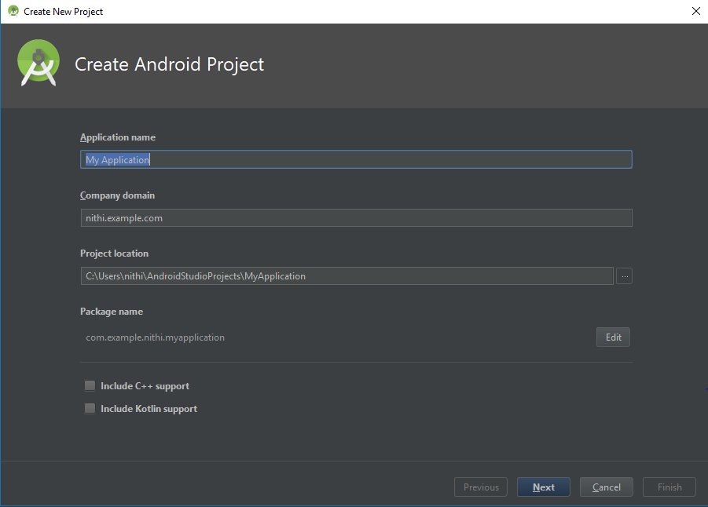

**TESTING TOOLS**: Testing will be carried out after the development in each stage in real time and various online tools are also available.

TestComplete Mobile is the testing tool which we are planned to test the application.

Also, the test will be conducted with the help of clients and with different user groups to collect the feedback at different stages of the development.

**SLACK CHANNEL:** Slack tool is used to communicate and manage the work within the team for the project.

Link: <https://stratagem10.slack.com>

